1. Initial Setup.

1. Adding components and adding their labels:

2911-Router - 2

3650-24PS-Switch – 1

2960-24TT – 8

PC - 8

Server - 3

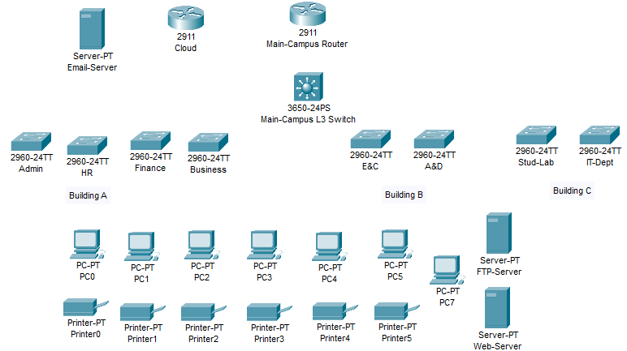

1. Serial Connection to Main Router and Cloud.

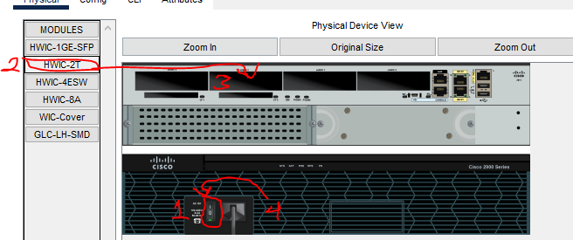

On Main Router, switch it off first, then move the HWIC-2T module to an empty slot then turn on again. Same process to 2911 Cloud Router.

1. Use automatic wires to connect other Devices.

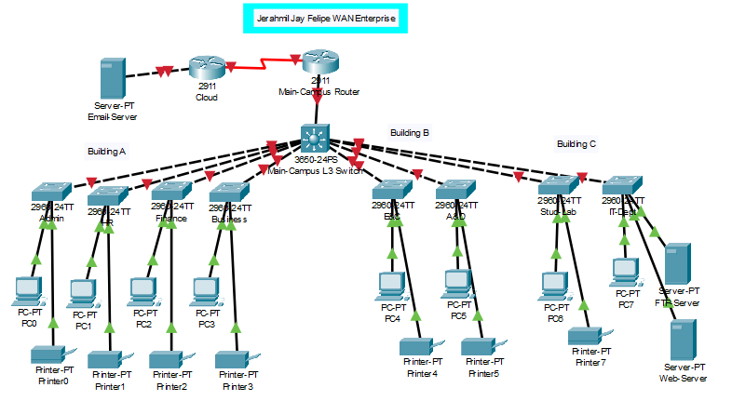

1. Design on preference.

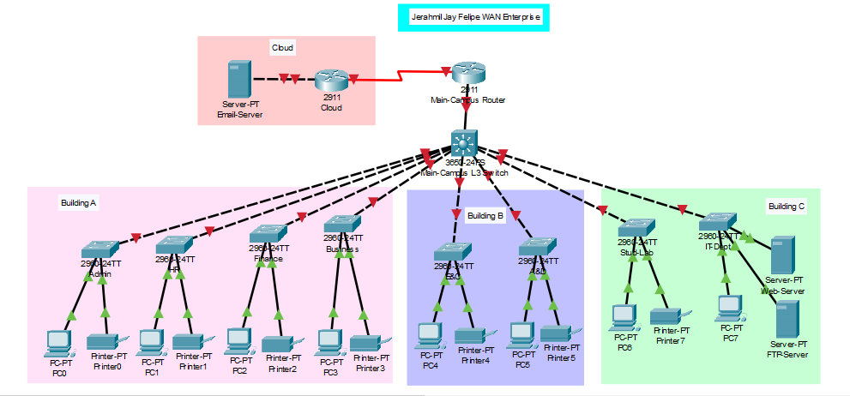

1. Add the Branch Devices.

1. Configure the 2911 Switch Branch here as Main-Campus Router to use series connection and connect it.

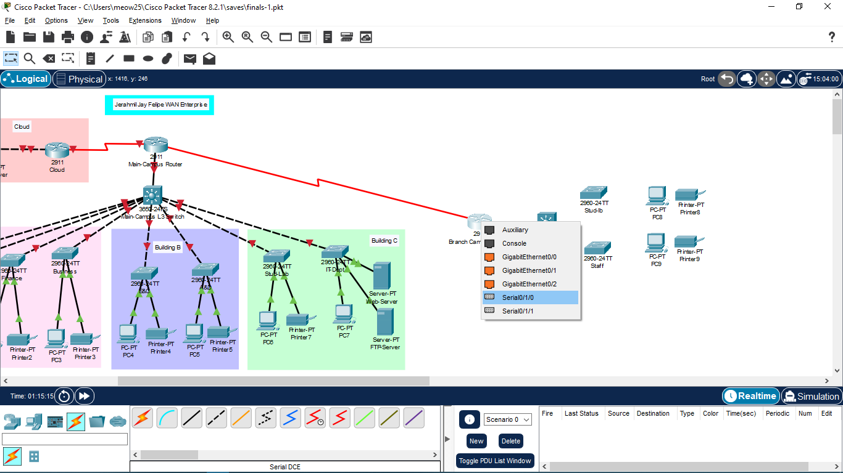

1. Design and Correct Labels for configuration.

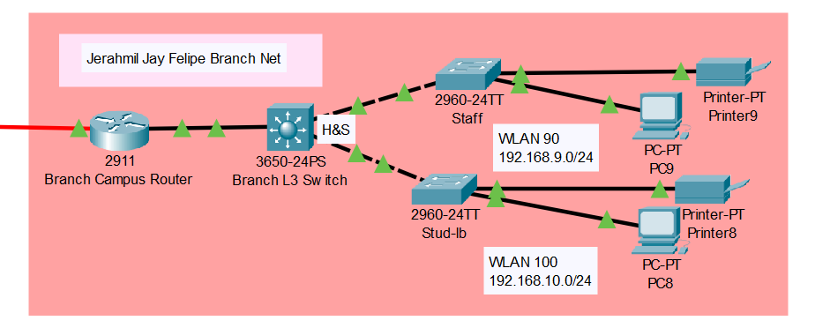

Current Overall Output:

